
Department of BES-1
DATA STRUCTURES USING PYTHON
I-B.Tech-(II Sem), Academic Year: 2024-2025

Session-4 Shell Sort
Aim:
To familiarize students with the basic concept of Shell Sort
Instructional Objective:

This Session is designed to:
- Demonstrate Shell sort
- Describe sorting technique work
- List out the steps of the sorting algorithm

Learning Outcomes:

At the end of this session, you should be able to:
- Define Shell Sort
- Describe algorithm and complexity of Shell Sort
- Summarize Shell Sort

Introduction:
Shell sort (also called diminishing increment sort) was invented by Donald Shell. This sorting algorithm is a generalization of insertion sort. Insertion sort works efficiently on input that is already almost sorted. Shell sort is also known as n-gap insertion sort. Instead of comparing only the adjacent pair, shell sort makes several passes and uses various gaps between adjacent elements (ending with the gap of 1 or classical insertion sort).
In insertion sort, comparisons are made between the adjacent elements. At most 1 inversion is eliminated for each comparison done with insertion sort. The variation used in shell sort is to avoid comparing adjacent elements until the last step of the algorithm. So, the last step of shell sort is effectively the insertion sort algorithm. It improves insertion sort by allowing the comparison and exchange of elements that are far away. This is the first algorithm which got less than quadratic complexity among comparison sort algorithms.
Shell sort is actually a simple extension for insertion sort. The primary difference is its capability of exchanging elements that are far apart, making it considerably faster for elements to get to where they should be. For example, if the smallest element happens to be at the end of an array, with insertion sort it will require the full array of steps to put this element at the beginning of the array. However, with shell sort, this element can jump more than one step a time and reach the proper destination in fewer exchanges.
The basic idea in shell sort is to exchange every h^{th} element in the array. Now this can be confusing so we’ll talk more about this, h determines how far apart element exchange can happen, say for example take h as 13, the first element (index-0) is exchanged with the 14th element (index-13) if necessary (of course). The second element with the 15th element, and so on. Now if we take h as 1, it is exactly the same as a regular insertion sort.
Shell sort works by starting with big enough (but not larger than the array size) h so as to allow eligible element exchanges that are far apart. Once a sort is complete with a particular h, the array can be said as h-sorted. The next step is to reduce h by a certain sequence, and again perform another complete h-sort. Once h is 1 and h-sorted, the array is completely sorted. Notice that the last sequence for ft is 1 so the last sort is always an insertion sort, except by this time the array is already well-formed and easier to sort.
Shell sort uses a sequence h1,h2, ...,ht called the increment sequence. Any increment sequence is fine as long as h1 = 1, and some choices are better than others. Shell sort makes multiple passes through the input list and sorts a number of equally sized sets using the insertion sort. Shell sort improves the efficiency of insertion sort by quickly shifting values to their destination.

Algorithm:

Step 1 − Start
Step 2 − Initialize the value of gap size. Example: h
Step 3 − Divide the list into smaller sub-part. Each must have equal intervals to h
Step 4 − Sort these sub-lists using insertion sort
Step 5 – Repeat this step 2 until the list is sorted.
Step 6 – Print a sorted list.
Step 7 – Stop.

Working of Shell Sort
Suppose, we need to sort the following array
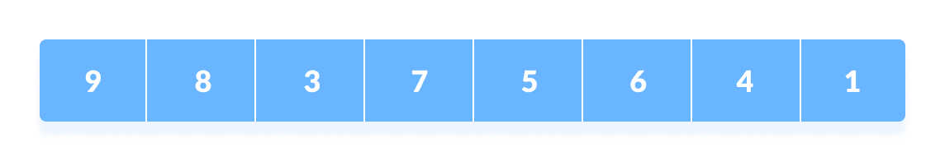
- We are using the shell's original sequence (N/2, N/4, ...1) as intervals in our algorithm.
- In the first loop, if the array size is N = 8 then, the elements lying at the interval of N/2 = 4 are compared and swapped if they are not in order.
- The 0th element is compared with the 4th element.
- If the 0th element is greater than the 4th one then, the 4th element is first stored in temp variable and the 0th element (ie. greater element) is stored in the 4th position and the element stored in temp is stored in the 0th position.
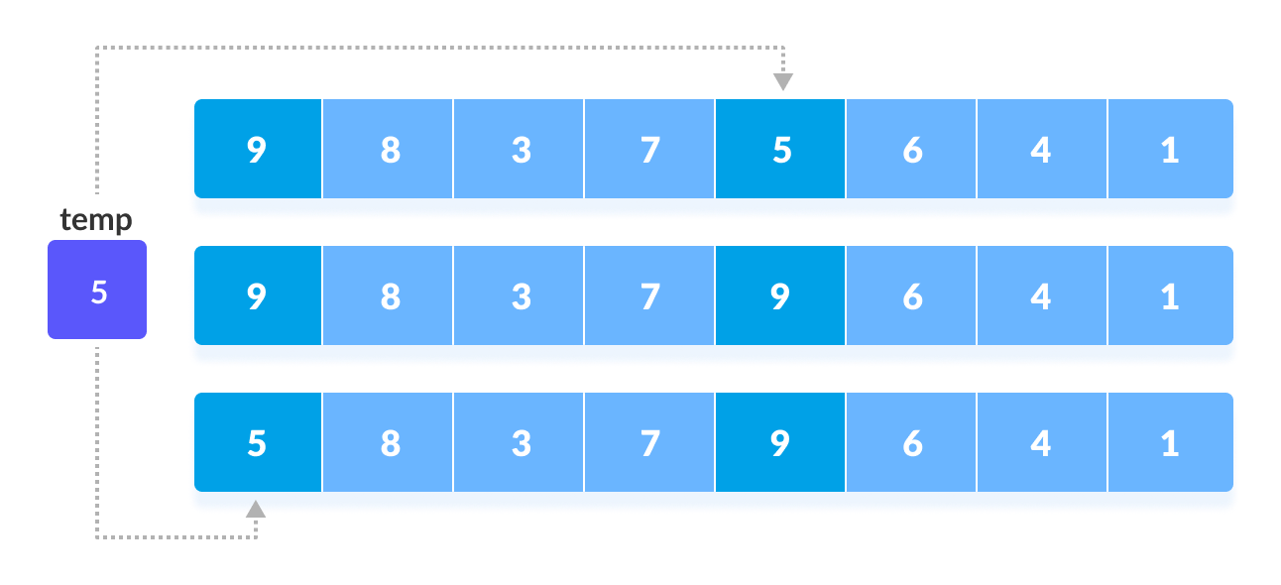
- This process goes on for all the remaining elements.
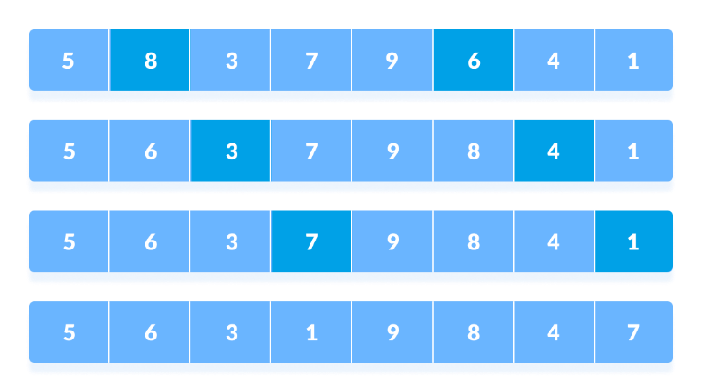
- In the second loop, an interval of N/4 = 8/4 = 2 is taken and again the elements lying at these intervals are sorted
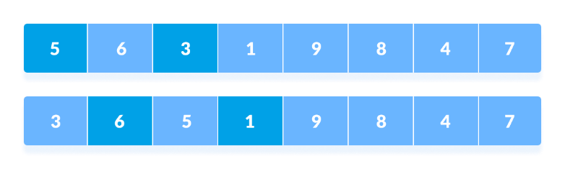
- The elements at 4th and 2nd position are compared. The elements at 2nd and 0th position are also compared. All the elements in the array lying at the current interval are compared.
- The same process goes on for remaining elements
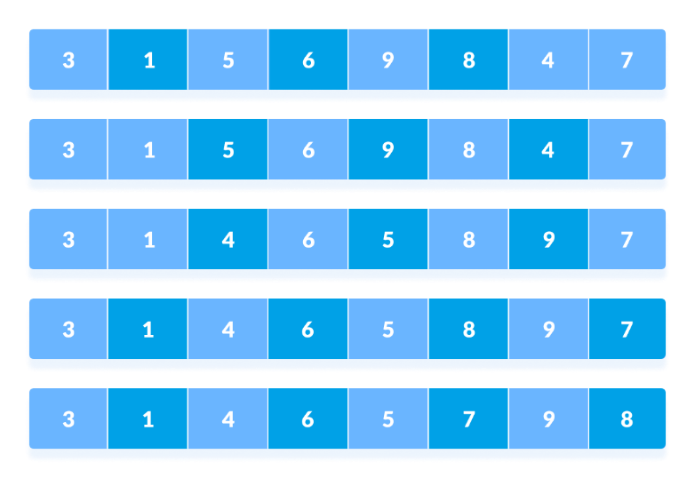
- Finally, when the interval is N/8 = 8/8 =1 then the array elements lying at the interval of 1 are sorted. The array is now completely sorted.
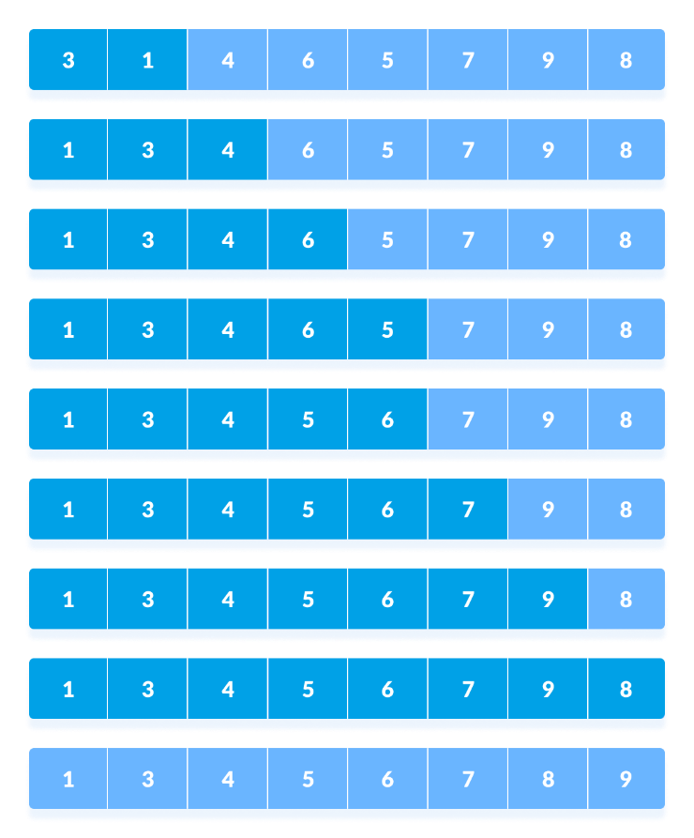

Pseudocode for Shell sort

Procedure begin: Shell sort
Calculate gap size ($gap)
WHILE $gap is greater than 0
FOR each element of the list, that is $gap apart
Extract the current item
Locate the position to insert
Insert the item to the position
END FOR
Calculate gap size ($gap)
END WHILE
End procedure
Note: Initially the $gap is half of length of the array and the $gap size is recalculated by dividing the gap by 2 every time

Analysis of Shell Sort
Shell sort is efficient for medium size arrays. For bigger arrays, the algorithm is not the best choice. It is the fastest of all O(n 2 ) sorting algorithms. The disadvantage of Shell sort is that it is a complex algorithm and not nearly as efficient as the merge, heap, and quick sorts. Shell sort is significantly slower than the merge, heap, and quick sorts, but is a relatively simple algorithm, which makes it a good choice for sorting lists of less than 5000 items unless speed is important. It is also a good choice for repetitive sorting of smaller arrays. The best case in Shell sort is when the array is already sorted in the right order. The number of comparisons is less. The running time of Shell sort depends on the choice of increment sequence.

Worst case complexity depends on gap sequence. Generally considered as O(n²)
Best case complexity: O(nlog(n))
Average case complexity depends on gap sequence. Normally considered as O(nlog(n))

Summery
Shell Sort is mainly a variation of Insertion Sort. In insertion sort, we move elements only one position ahead. When an element has to be moved far ahead, many movements are involved. The idea of Shell Sort is to allow the exchange of far items. In Shell sort, we make the array h-sorted for a large value of h. We keep reducing the value of h until it becomes 1. An array is said to be h-sorted if all sublists of every h^{th} element are sorted.

Self-assessment questions:

- What is the other name for a shell sort algorithm?
  - Diminishing increment sort
  - Diminishing decrement sort
  - Insertion Sort
  - Selection Sort

- The worst case running time of shell sort, using Shell’s increments is?
  - O(N)
  - O(N log N)
  - O(log N)
  - O(N²)

Terminal questions

- Describe what is Shell sort
- List out steps involved in Shell sort
- Analyze complexity of Shell sort
- Summarize the working principle of Shell sort

Practice Problems

Given a list of N array elements apply shell sort on array using Shellsort algorithm
Input Format
The first line contains the integer N, the size of the array. The next line contains N space-separated integers.
Constraints
• 1<=N<=1000
• -1000<=a[i]<=1000
Output Format
Print the array as a row of space-separated integers in each iteration.

REFERENCES FOR FURTHER LEARNING OF THE SESSION:

Reference Books:
- Data Structures and Algorithm Analysis in PYTHON, 2010, Mark Allen Weiss, Second Edition, Pearson Education.
- Data Structures and Algorithms, A.V.Aho, J.E.Hopcroft, and J.D.Ullman, Pearson Education, First Edition Reprint2003.
- Advanced Guide to Python 3 Programming, John Hunt, 4th Edition, Springer Nature Switzerland AG 2019.
- Python Basics: A Practice Introduction to Python 3, David Amos, Dan Bader, Joanna Jablonski, Fletcher Heisler, 4th edition, Real Python.

Sites and Web links:
  - https://docs.python.org/3/tutorial/datastructures.html
  - https://www.w3schools.com/dsa/dsa_intro.php
  - https://www.geeksforgeeks.org/python-data-structures/
  - https://onlinecourses.nptel.ac.in/noc25_cs59/preview
  - https://www.coursera.org/learn/python-data
  - https://www.codecademy.com/learn/learn-data-structures-and-algorithms-with-python

